Robert Call

Linux Admin

10/18/21

**Continue Setup Installing Repositories and programs**

Centos 8:

1. Q. How to check for repositories on your server (show existing ones and new ones)

To find your list of repositories on Centos 8

1. To check for local Repositories or ones you have installed on Centos 8 you use the command yum repolist.

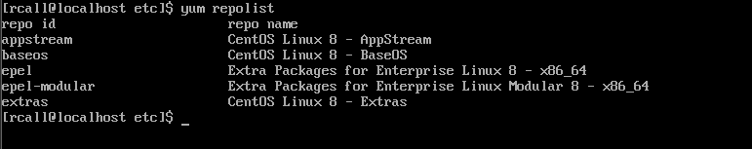

1. Adding a Repository
2. Making sure you can install programs
3. How to Install Tmux
4. How to install emacs
5. How to install fail2ban
6. How to install cowsay
7. How to install lolcat
8. Update vi to vim if necessary